Wichita Eagle
MAY 30, 2017 6:56 AM

Architects see 50-year-old Wichita library as brutally honest
BY TIM POTTER
tpotter@wichitaeagle.com
Eric Wittman is a 36-year-old architect in Portland, Maine, but his architectural heart is still drawn to Wichita’s main library. As a kid, he checked out books there. And by the time he was a young architect, he admired its design. His mind’s eye conjures up and gazes at that 50-year-old structure and its Brutalist style of Midcentury Modern design.
“Modern” in an architectural sense basically means “simple and open.” “Brutalist” is a style involving raw, exposed concrete in bold geometric shapes, often erected in the 1950s and 1960s. Depending on the eye and taste, the style can be seen as ugly or cool. Last year, a headline in the New York Times Style Magazine announced: “Brutalism is back.”
Crews erected the Wichita main library in 1967, when Lyndon Johnson was president and hippies were flocking to San Francisco. In 1968, the library received a national design award from the American Institute of Architects, said Terry Wiggers, executive vice president of SJCF Architecture in Wichita. Its predecessor firm, Schaefer Schirmer & Eflin Architects, designed the library.
According to the panel that gave the award, the building functioned well and offered a “pleasant and inviting interior” and an exterior “in harmony in mass and proportion with its surroundings.”
Dean Bradley, a 65-year-old architect in Wichita, can still appreciate the building in person.
Bradley and Wittman – two architects born decades apart – are raving about the library’s architectural significance at a time when the future of the building is uncertain. A new main library is under construction across the river. In a recent phone conversation about plans for the 1967 building, Mayor Jeff Longwell said, “We don’t have any plans for it.”
The city has received inquiries from potential buyers, Longwell said, but it’s too early to determine the building’s fate.
Greg Kite, president of the Historic Preservation Alliance of Wichita and Sedgwick County, said, “We certainly would like to see it re-purposed in some way.”

‘Very honest building’
You might not notice the concrete building or know its significance if you are driving past it at Douglas and Main. It’s not as dominant as the big blue roof next door at the Century II performing arts and convention center, which also is seen by some as a Midcentury Modern gem with an uncertain future.
Wittman and Bradley can explain why the library design is special in their eyes.
“It’s a very honest building, and when I say honest … its structure is concrete,” Wittman said. No ornamentation hides the underlying structure. It’s bare; it’s Brutalist.
“To me,” Wittman said, “the Brutalist architecture kind of reminds me of the hippies of the period” – simple and humble but still stout and functional.
Bradley, the Wichita architect, said some consider the library to be a “Brutalist interpretation of the Prairie Style.” The Prairie Style features horizontal lines, sits “well-connected to the ground” and uses natural materials. Here’s what Bradley sees in the library: “The structure is right out there for everyone to see. Concrete piers rise from this platform, then turn up and go into concrete beams.” The lower level is sunken. Then the building “starts stepping out” as it rises, with the top floor farther out.
As unadorned as it is, Bradley said, it’s still refined, with a warm hue. It’s not just any old, drab concrete. If you rub your hand across an interior wall, you can feel smooth pebbles.
“A lot of projects hide the structure, but this one is right out in the open. Of course, at night, it just looks like a jewel. You see the simplicity from the outside when you’re looking in. “It’s part of the fabric of downtown,” Bradley said. At lunchtime, he often walks to the library from his office across Douglas. Sometimes, he does research there.
The wide-open interior takes the eye to multiple levels visible from the mezzanine. Quality wood trim dresses the interior. The wood flows simply, in a straight-line, functional way. “No fancy crown molds,” Bradley said. The whole effect “invites you in,” he said. “The challenge is how to find a new use that honors the design.”
Bradley sees the library building as a pillar in a group of four architecturally and historically significant buildings that remain in the Douglas and Main corridors downtown: the highly ornamental 1892 old City Hall building, with its native stone and landmark clock tower; the 1915 Carnegie Library next door to the south; the 1967 Brutalist library across the street; and the 1969 Frank Lloyd Wright-influenced Century II. They represent different styles and embody 80 years of Wichita history.
They remain key buildings, he said. “That forms the civic center of Wichita. You take elements out or away, and they all suffer.”

‘This is in my city’
Bradley and Wittman talk about how the grounds around the library are laid out in a grid – with walls, benches and walkways matching the grid pattern on the building. It was done with a purpose, Wittman said: “They wanted you to enter the building when you are on the outside of it. Architects just don’t do that anymore. You don’t have the budgets.” To Bradley, the grounds help visitors leave the “hustle and bustle” as they approach the library.
In the years before Wittman moved from Wichita to Maine, he would go to the library not just to rent DVDs but to look at it through his architectural lens. Each time, he would tell himself: “I can’t believe this in my city.” Boston built a Brutalist city hall after Wichita constructed its Brutalist library, he said. “We were doing more modern architecture than a bigger city.” Still, he’s concerned about the future of the library building and whether it will be torn down. “I know that the building’s not going to be saved just because architects think it’s pretty.”
There’s a tendency in Wichita to vacate and demolish significant buildings when they turn around 50 years old, he said. To some, the buildings become disposable at that point: too old to be “new” but not old enough to be historic. Once a building survives beyond 50 years, he said, “it’s almost as if you’re in the clear.” Wittman hopes the library building can serve a new use, just as the old Union Station on Douglas has been re-purposed.
“It’s a good building, and good buildings adapt.”
FACEBOOK TWITTER
Tim Potter: 316-268-6684, @timpotter59
The Wichita Public Library’s architectural style of the main branch downtown has been described as Brutalist. (May 26, 2017) Bo Rader The Wichita Eagle
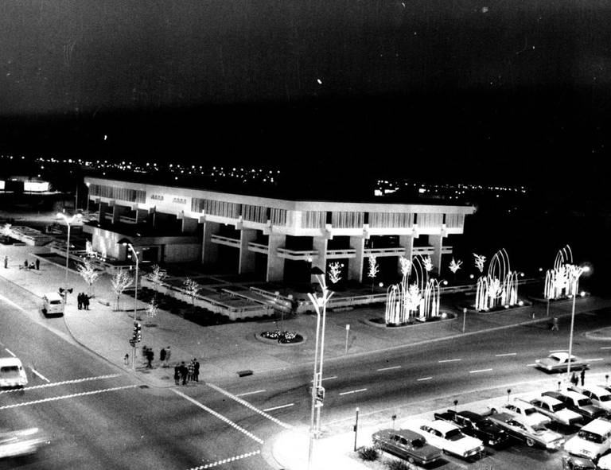
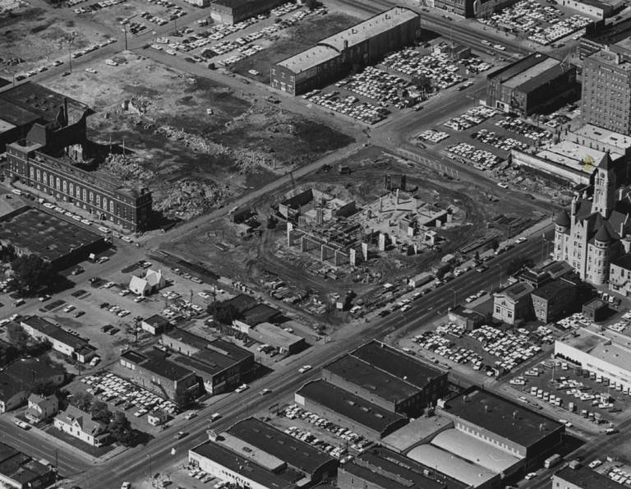
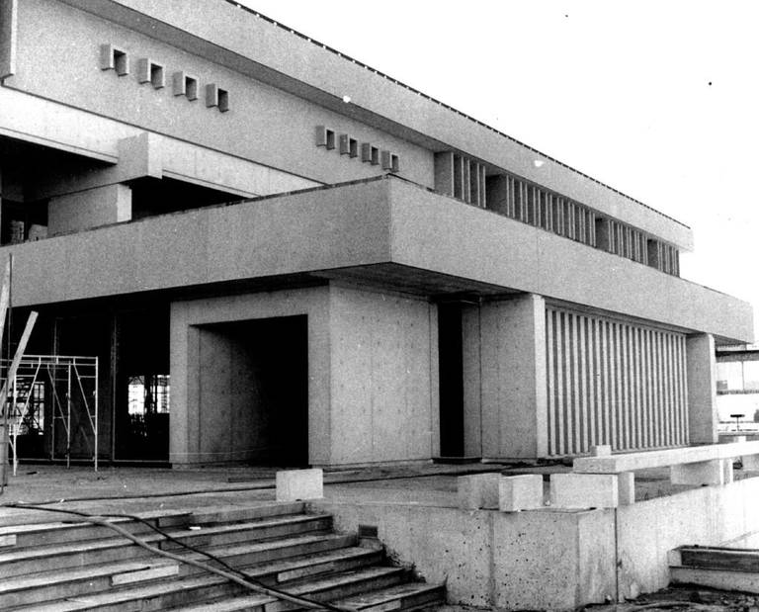

In this photo taken in the mid-1960s, the city library downtown is growing in the center, while only a shell remains at left of the old Forum building. Robert Ames The Wichita Eagle/John Rogers Partners

